- Data Source and Analytical Framework

This analysis examines temporal, demographic, and geographic trends in reported measles cases in Saudi Arabia between 2014 and 2023, based on surveillance data. Using descriptive statistics and incidence rates, general patterns were identified, and regional variations were assessed through population-adjusted observed-to-expected (O/E) case ratios, multi-group simulations, and a geographic concentration index. Due to data limitations, the analysis of age groups and the monthly distribution at the national level remained restricted.

- National Monthly Distribution and Temporal Patterns of Reported Measles Cases

The monthly case counts were organized and converted into annual percentages. In the figure below, we display two heatmaps; the first shows the absolute number of cases while the second shows monthly percentages, allowing for a seasonal comparison.
We display these figures side-by-side, making it easy to distinguish the distribution throughout the year (Figure 1).
Monthly Counts
Year | Jan | Feb | Mar | Apr | May | Jun | Jul | Aug | Sep | Oct | Nov | Dec
2014 | 17 | 20 | 17 | 18 | 16 | 10 | 4 | 7 | 5 | 13 | 13 | 14
2015 | 20 | 6 | 4 | 38 | 54 | 51 | 17 | 15 | 5 | 5 | 4 | 0
2016 | 4 | 9 | 8 | 4 | 7 | 6 | 19 | 23 | 6 | 12 | 9 | 18
2017 | 82 | 84 | 39 | 26 | 17 | 8 | 17 | 13 | 28 | 27 | 53 | 63
2018 | 73 | 105 | 185 | 251 | 169 | 73 | 69 | 34 | 39 | 52 | 51 | 55
2019 | 292 | 424 | 157 | 62 | 19 | 26 | 14 | 13 | 1 | 3 | 12 | 1
2020 | 5 | 8 | 12 | 7 | 1 | 0 | 0 | 0 | 0 | 0 | 0 | 1
2021 | 0 | 1 | 2 | 0 | 3 | 3 | 1 | 1 | 67 | 123 | 96 | 30
2022 | 18 | 3 | 6 | 1 | 10 | 33 | 15 | 39 | 40 | 20 | 27 | 35
2023 | 110 | 161 | 400 | 351 | 372 | 243 | 191 | 152 | 96 | 71 | 47 | 60
Monthly Percentages
Year | Jan | Feb | Mar | Apr | May | Jun | Jul | Aug | Sep | Oct | Nov | Dec
2014 | 11,039 | 12,987 | 11,039 | 11,6883 | 10,3896 | 6,4935 | 2,5974 | 4,5455 | 3,2468 | 8,4416 | 8,4416 | 9,0909
2015 | 9,1324 | 2,7397 | 1,8265 | 17,3516 | 24,6575 | 23,2877 | 7,7626 | 6,8493 | 2,2831 | 2,2831 | 1,8265 | 0
2016 | 3,2 | 7,2 | 6,4 | 3,2 | 5,6 | 4,8 | 15,2 | 18,4 | 4,8 | 9,6 | 7,2 | 14,4
2017 | 17,9431 | 18,3807 | 8,5339 | 5,6893 | 3,7199 | 1,7505 | 3,7199 | 2,8446 | 6,1269 | 5,9081 | 11,5974 | 13,7856
2018 | 6,3149 | 9,083 | 16,0035 | 21,7128 | 14,6194 | 6,3149 | 5,9689 | 2,9412 | 3,3737 | 4,4983 | 4,4118 | 4,7578
2019 | 28,5156 | 41,4062 | 15,332 | 6,0547 | 1,8555 | 2,5391 | 1,3672 | 1,2695 | 0,0977 | 0,293 | 1,1719 | 0,0977
2020 | 14,7059 | 23,5294 | 35,2941 | 20,5882 | 2,9412 | 0 | 0 | 0 | 0 | 0 | 0 | 2,9412
2021 | 0 | 0,3058 | 0,6116 | 0 | 0,9174 | 0,9174 | 0,3058 | 0,3058 | 20,4893 | 37,6147 | 29,3578 | 9,1743
2022 | 7,2874 | 1,2146 | 2,4291 | 0,4049 | 4,0486 | 13,3603 | 6,0729 | 15,7895 | 16,1943 | 8,0972 | 10,9312 | 14,17
2023 | 4,8802 | 7,1429 | 17,7462 | 15,5723 | 16,504 | 10,7808 | 8,4738 | 6,7436 | 4,2591 | 3,15 | 2,0852 | 2,6619

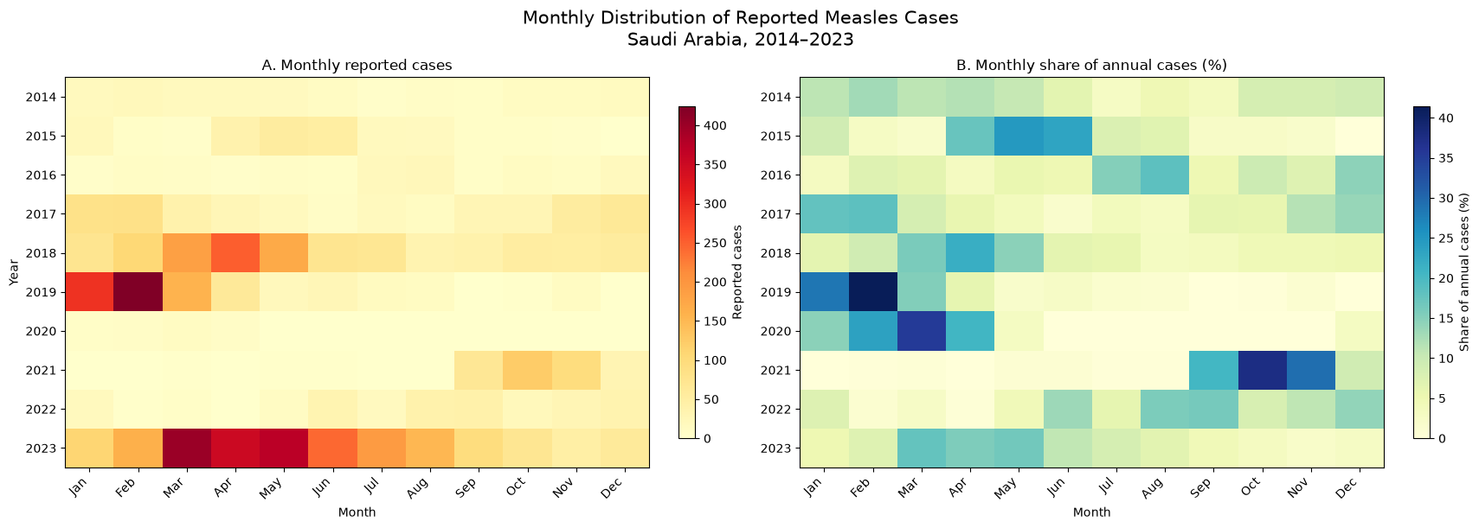
Figure 1
In order to see the intensity of measles cases in a year, we analyse the peak month and the three month peack. Then we calculate the percentages of all cases of that year happened during these period. We then display these figures side by side in a bar chart (Figure 2).

Monthly Distribution of Reported Measles Cases
Year | Annual cases | Peak month | Peak month cases | Peak month share (%) | Peak  3-month period | Peak  3-month cases | Peak  3-month share (%)
2014 | 154 | Feb | 20 | 12,99 | Feb–Apr | 55 | 35,71
2015 | 219 | May | 54 | 24,66 | Apr–Jun | 143 | 65,3
2016 | 125 | Aug | 23 | 18,4 | Jun–Aug | 48 | 38,4
2017 | 457 | Feb | 84 | 18,38 | Jan–Mar | 205 | 44,86
2018 | 1156 | Apr | 251 | 21,71 | Mar–May | 605 | 52,34
2019 | 1024 | Feb | 424 | 41,41 | Jan–Mar | 873 | 85,25
2020 | 34 | Mar | 12 | 35,29 | Feb–Apr | 27 | 79,41
2021 | 327 | Oct | 123 | 37,61 | Sep–Nov | 286 | 87,46
2022 | 247 | Sep | 40 | 16,19 | Aug–Oct | 99 | 40,08
2023 | 2254 | Mar | 400 | 17,75 | Mar–May | 1123 | 49,82

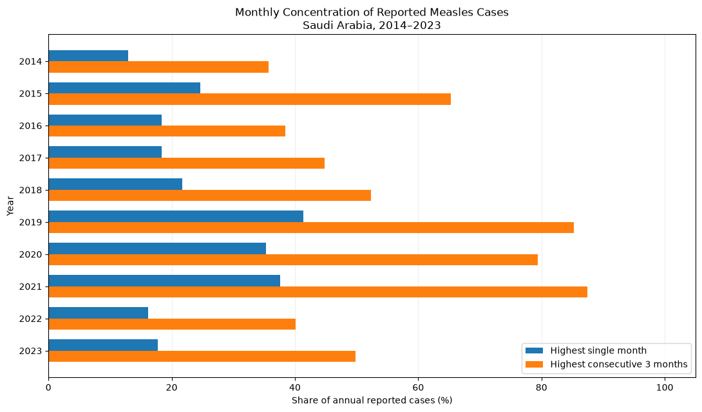
Figure 2

- National Age-Group Distribution

  - Annual Age-Group Distribution
Annual measles cases were grouped into five age categories. We calculated the percentage contribution of each group. We then display two stacked bar charts to visualize the case counts and percentage distribution across the study period (Figure 3, 4).

Annual Count
Year | <1 year | 1–4 years | 5–14 years | 15–44 years | 45+ years
2014 | 33 | 55 | 26 | 35 | 5
2015 | 65 | 73 | 21 | 55 | 5
2016 | 33 | 43 | 16 | 28 | 5
2017 | 164 | 132 | 58 | 90 | 13
2018 | 356 | 436 | 188 | 170 | 6
2019 | 403 | 391 | 122 | 97 | 11
2020 | 4 | 14 | 12 | 4 | 0
2021 | 94 | 120 | 25 | 86 | 2
2022 | 49 | 88 | 40 | 68 | 2
2023 | 561 | 916 | 565 | 185 | 27

Annual Percentage
Year | <1 year | 1–4 years | 5–14 years | 15–44 years | 45+ years
2014 | 21,4286 | 35,7143 | 16,8831 | 22,7273 | 3,2468
2015 | 29,6804 | 33,3333 | 9,589 | 25,1142 | 2,2831
2016 | 26,4 | 34,4 | 12,8 | 22,4 | 4
2017 | 35,8862 | 28,884 | 12,6915 | 19,6937 | 2,8446
2018 | 30,7958 | 37,7163 | 16,263 | 14,7059 | 0,519
2019 | 39,3555 | 38,1836 | 11,9141 | 9,4727 | 1,0742
2020 | 11,7647 | 41,1765 | 35,2941 | 11,7647 | 0
2021 | 28,7462 | 36,6972 | 7,6453 | 26,2997 | 0,6116
2022 | 19,8381 | 35,6275 | 16,1943 | 27,5304 | 0,8097
2023 | 24,8891 | 40,6389 | 25,0665 | 8,2076 | 1,1979

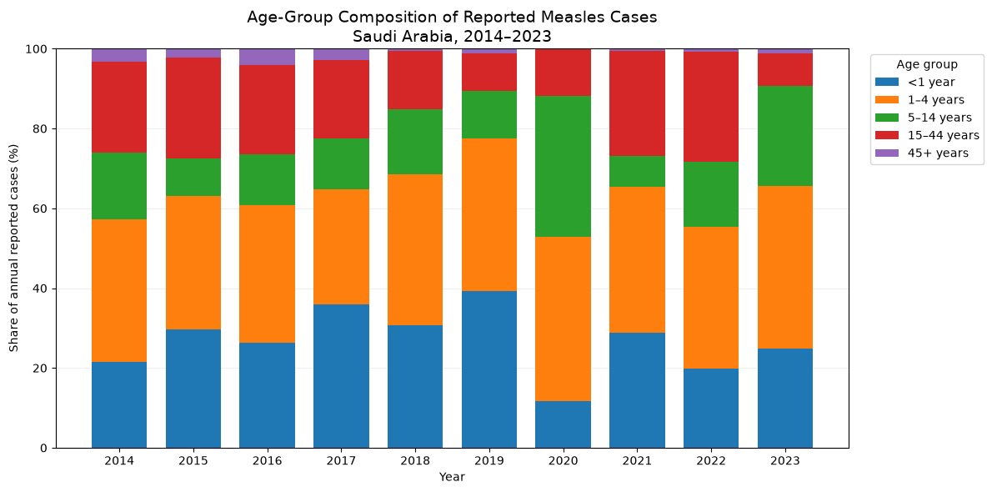
Figure 3

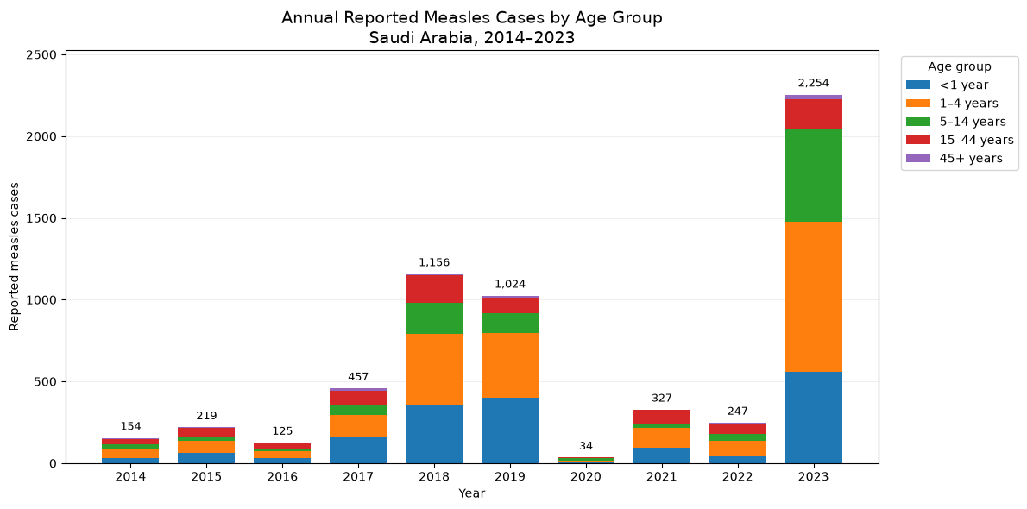
Figure 4

  - Age-Group Comparison of Major Measles Reporting Years
We used the three highest case years (2018, 2019, and 2023) to compare age groups and case counts and percentage distributions. We also calculated for each group to quantify its contribution to the overall increase.

Age group | 2019 cases | 2023 cases | Case difference | Share of total difference (%)
<1 year | 403 | 561 | 158 | 12,85
1–4 years | 391 | 916 | 525 | 42,68
5–14 years | 122 | 565 | 443 | 36,02
15–44 years | 97 | 185 | 88 | 7,15
45+ years | 11 | 27 | 16 | 1,3

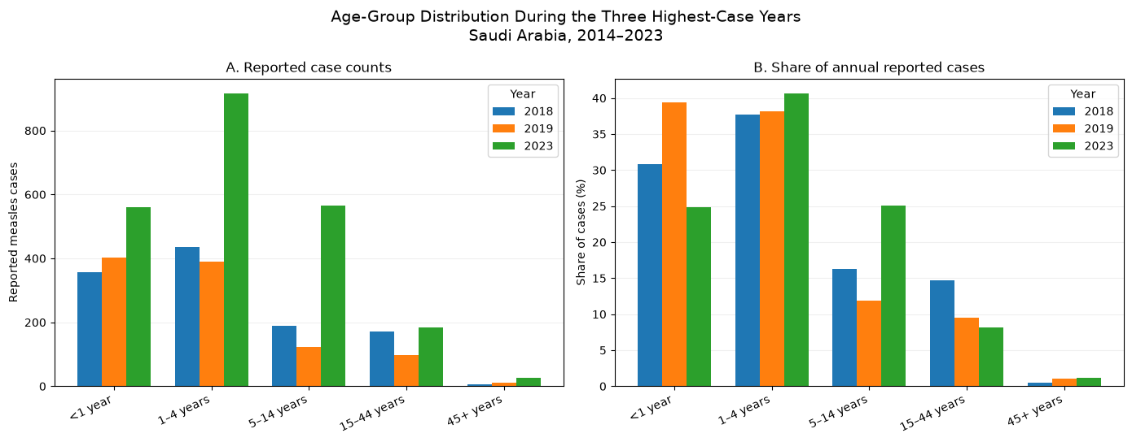
Figure 5

- Regional and Annual Incidence Heatmap
  - Liner heatmap
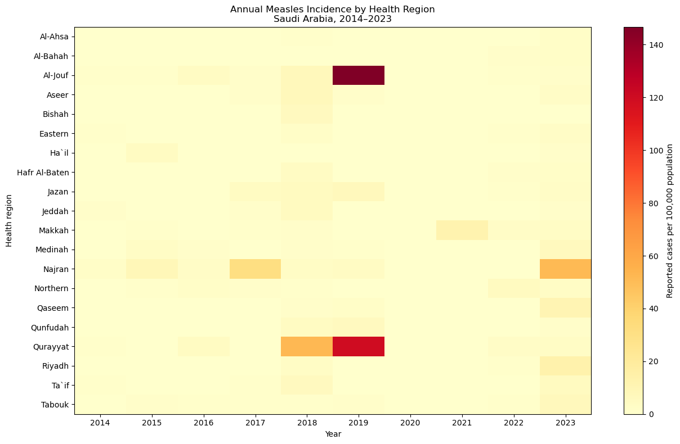
Figure 6
The map is pale and lacks contrast, making it difficult to distinguish meaningful differences among regions with lower incidence rates (Figure 6). Therefore, we use a logarithmic color transformation log1p, defined as: $y=\ln{(1+x)}$. (Figure 7)

  - Log-transformed heatmap
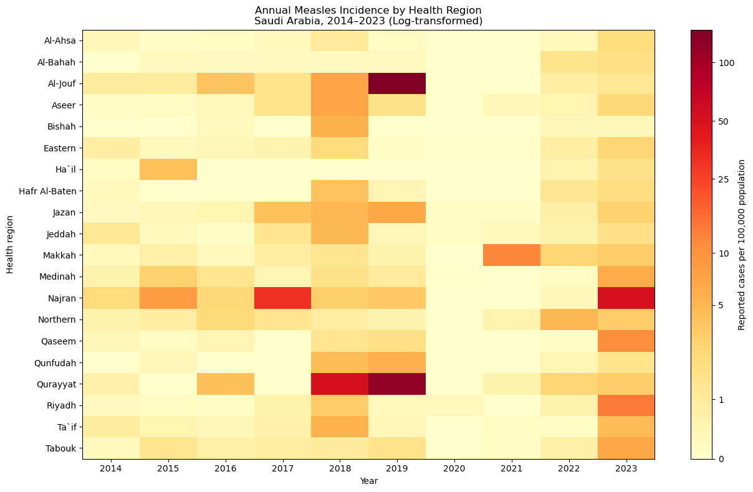
Figure 7
- Regional Annual Incidence Trajectories

We plotted the incident rates for each one of the 20 health regions (Figure 8).
Annual measles incidence rates were plotted separately for each of the 20 health regions.

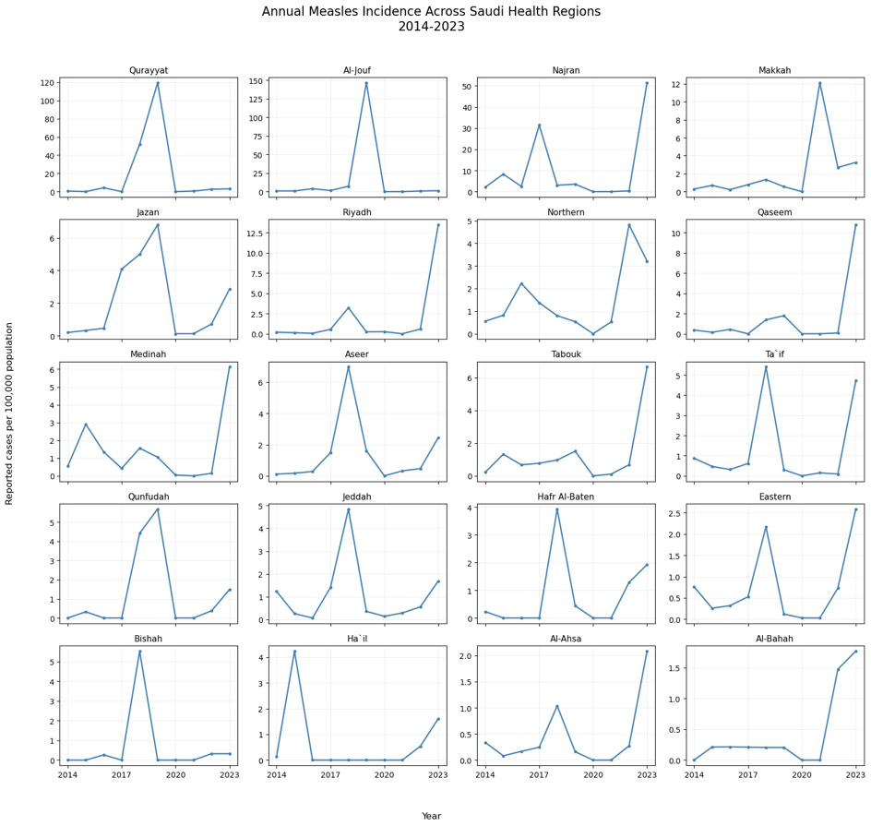
Figure 8

- Regional Peak-Year Concentration

We identified the year with the highest reported cases for each health region. Then we devided the peak year case count by the region’s total cases from 2014 to 2023. We then calculated the concentration percentage. Thn we displayed it in a bar chart (figure 9).

Health region | Peak year | Peak year cases | Total cases | Peak year share percentage
Al-Jouf | 2019 | 510 | 567 | 89,95%
Bishah | 2018 | 22 | 25 | 88,00%
Riyadh | 2023 | 1157 | 1600 | 72,31%
Qaseem | 2023 | 144 | 204 | 70,59%
Qurayyat | 2019 | 207 | 317 | 65,30%
Ha`il | 2015 | 29 | 46 | 63,04%
Makkah | 2021 | 297 | 545 | 54,50%
Aseer | 2018 | 130 | 253 | 51,38%
Tabouk | 2023 | 59 | 116 | 50,86%
Najran | 2023 | 305 | 603 | 50,58%
Hafr Al-Baten | 2018 | 18 | 36 | 50,00%
Qunfudah | 2019 | 18 | 38 | 47,37%
Jeddah | 2018 | 231 | 489 | 47,24%
Al-Ahsa | 2023 | 23 | 51 | 45,10%
Ta`if | 2018 | 72 | 160 | 45,00%
Medinah | 2023 | 131 | 300 | 43,67%
Al-Bahah | 2023 | 6 | 16 | 37,50%
Eastern | 2023 | 92 | 254 | 36,22%
Jazan | 2019 | 109 | 322 | 33,85%
Northern | 2022 | 18 | 55 | 32,73%

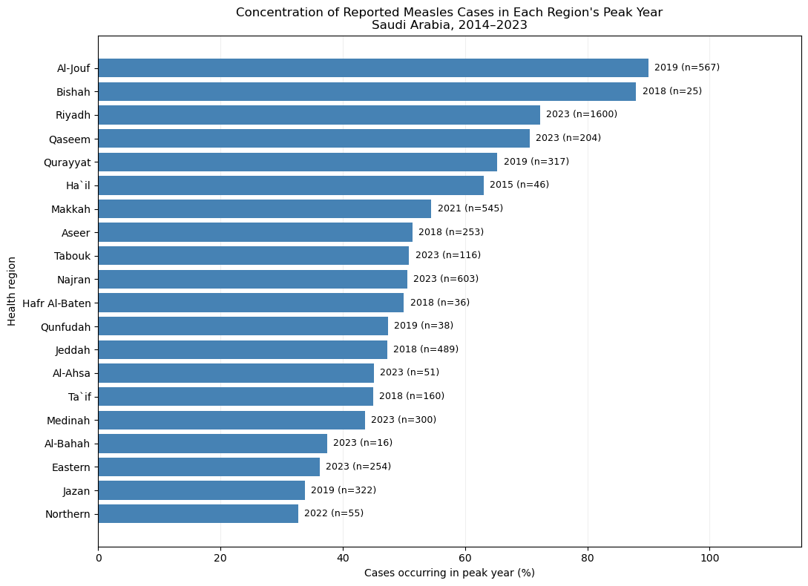
Figure 9

- Geographic Composition of Major Measles Reporting Years

We selected the highest three years with case counts (2018, 2019, 2023). We then calculate the percentage contribution of each region to the national total. We then viulised it in a stack bar(Figure 10).

Regional Contributions to National Measles Cases in 2018, 2019, and 2023 (%)
Year | Riyadh | Jeddah | Aseer | Qurayyat | Jazan | Al-Jouf | Qaseem | Najran | Medinah | Eastern | Other regions
2018 | 23,5294 | 19,9827 | 11,2457 | 7,7855 | 6,9204 | 2,1626 | 1,7301 | 1,5571 | 2,9412 | 6,2284 | 15,917
2019 | 2,0508 | 1,6602 | 2,9297 | 20,2148 | 10,6445 | 49,8047 | 2,5391 | 2,0508 | 2,2461 | 0,3906 | 5,4688
2023 | 51,331 | 2,9725 | 1,8634 | 0,2662 | 1,7746 | 0,2218 | 6,3886 | 13,5315 | 5,8119 | 4,0816 | 11,7569

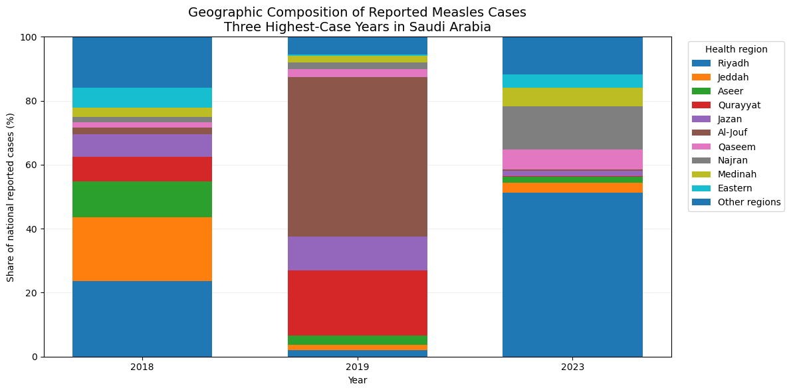
Figure 10

- Observed-to-expected (O/E) ratio

$${O/E}_{r}=\frac{O_{r}}{E_{r}}$$
Where:
$O_{r}$: Total observed cases in region $r$ over 2014-2023
$E_{r}$: Total expected cases, calculated using the corresponding national annual incidence rates and that region's annual populations.
$$E_{r}=\sum_{t=2014}^{2023}{(\frac{C_{t}}{P_{t}}×P_{r,t})}$$
$C_{t}$ is the national case count, $P_{t}$ is the national population, and $P_{r,t}$ is the regional population in year $t$.
For each health region, the total observed measles cases during 2014–2023 were compared with the expected cases, calculated using annual national incidence rates and corresponding regional populations. The observed-to-expected (O/E) ratio was then calculated to assess regional differences relative to the national reference. The 95% confidence interval (CI) provides a range of plausible values for the O/E ratio. The lower and upper limits define this range and reflect uncertainty in the estimated ratio (Figure 11).

Observed-to-Expected Measles Cases and 95% Confidence Intervals by Health Region (2014–2023)
Health region | Observed cases | Expected cases | Total population exposure | O/E ratio | 95% CI lower (source) | 95% CI upper (source)
Qurayyat | 317 | 33.365 | 1,763,900 | 9.501 | 8.484 | 10.607
Al-Jouf | 567 | 67.631 | 3,551,052 | 8.384 | 7.708 | 9.103
Najran | 603 | 108.627 | 5,906,522 | 5.551 | 5.117 | 6.012
Makkah | 545 | 456.722 | 23,919,901 | 1.193 | 1.095 | 1.298
Jazan | 322 | 277.746 | 15,528,022 | 1.159 | 1.036 | 1.293
Riyadh | 1600 | 1,550.511 | 83,417,447 | 1.032 | 0.982 | 1.084
Northern | 55 | 68.465 | 3,722,828 | 0.803 | 0.605 | 1.046
Qaseem | 204 | 256.654 | 14,181,605 | 0.795 | 0.690 | 0.912
Aseer | 253 | 328.866 | 18,168,190 | 0.769 | 0.677 | 0.870
Medinah | 300 | 395.170 | 21,473,746 | 0.759 | 0.676 | 0.850
Ta`if | 160 | 225.420 | 12,735,124 | 0.710 | 0.604 | 0.829
Qunfudah | 38 | 54.343 | 3,056,697 | 0.699 | 0.495 | 0.960
Tabouk | 116 | 166.649 | 9,147,824 | 0.696 | 0.575 | 0.835
Jeddah | 489 | 805.627 | 45,118,915 | 0.607 | 0.554 | 0.663
Hafr Al-Baten | 36 | 84.397 | 4,563,071 | 0.427 | 0.299 | 0.591
Eastern | 254 | 622.873 | 33,105,189 | 0.408 | 0.359 | 0.461
Bishah | 25 | 65.910 | 3,775,568 | 0.379 | 0.245 | 0.560
Ha`il | 46 | 133.105 | 7,143,656 | 0.346 | 0.253 | 0.461
Al-Ahsa | 51 | 217.426 | 12,132,673 | 0.235 | 0.175 | 0.308
Al-Bahah | 16 | 77.494 | 4,531,270 | 0.206 | 0.118 | 0.335

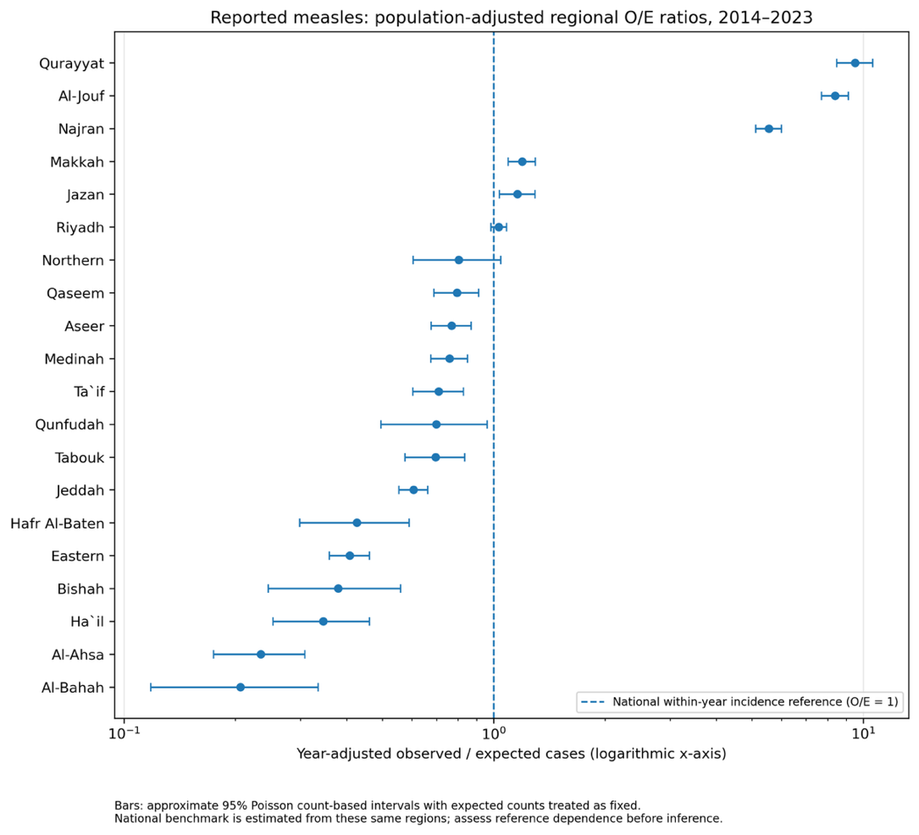
Figure 11
  - Sensitivity Analysis of Regional O/E Ratios
Regional O/E ratios were recalculated after separately excluding the peak years (2018, 2019, and 2023). Both observed and expected cases were recomputed for each scenario to assess how individual high-case years influenced the regional comparisons (Figure 12).

Regional O/E Ratios Following Exclusion of Major Reporting
Health region | Total cases | Population exposure | Incidence per 100k | Population share | Case share | Total cases
Al-Bahah | 16 | 4531270 | 0,353102 | 0,013860 | 0,002668 | Al-Bahah
Al-Ahsa | 51 | 12132673 | 0,420353 | 0,037109 | 0,008504 | Al-Ahsa
Ha`il | 46 | 7143656 | 0,643928 | 0,021850 | 0,007671 | Ha`il
Bishah | 25 | 3775568 | 0,662152 | 0,011548 | 0,004169 | Bishah
Eastern | 254 | 33105189 | 0,767251 | 0,101257 | 0,042355 | Eastern
Hafr Al-Baten | 36 | 4563071 | 0,788942 | 0,013957 | 0,006003 | Hafr Al-Baten
Jeddah | 489 | 45118915 | 1,083803 | 0,138002 | 0,081541 | Jeddah
Qunfudah | 38 | 3056697 | 1,243172 | 0,009349 | 0,006337 | Qunfudah
Ta`if | 160 | 12735124 | 1,256368 | 0,038952 | 0,026680 | Ta`if
Tabouk | 116 | 9147824 | 1,268061 | 0,027980 | 0,019343 | Tabouk
Aseer | 253 | 18168190 | 1,392544 | 0,055570 | 0,042188 | Aseer
Medinah | 300 | 21473746 | 1,397055 | 0,065680 | 0,050025 | Medinah
Qaseem | 204 | 14181605 | 1,438483 | 0,043376 | 0,034017 | Qaseem
Northern | 55 | 3722828 | 1,477372 | 0,011387 | 0,009171 | Northern
Riyadh | 1600 | 83417447 | 1,918064 | 0,255144 | 0,266800 | Riyadh
Jazan | 322 | 15528022 | 2,073670 | 0,047495 | 0,053694 | Jazan
Makkah | 545 | 23919901 | 2,278438 | 0,073162 | 0,090879 | Makkah
Najran | 603 | 5906522 | 10,209054 | 0,018066 | 0,100550 | Najran
Al-Jouf | 567 | 3551052 | 15,967099 | 0,010861 | 0,094547 | Al-Jouf
Qurayyat | 317 | 1763900 | 17,971540 | 0,005395 | 0,052860 | Qurayyat

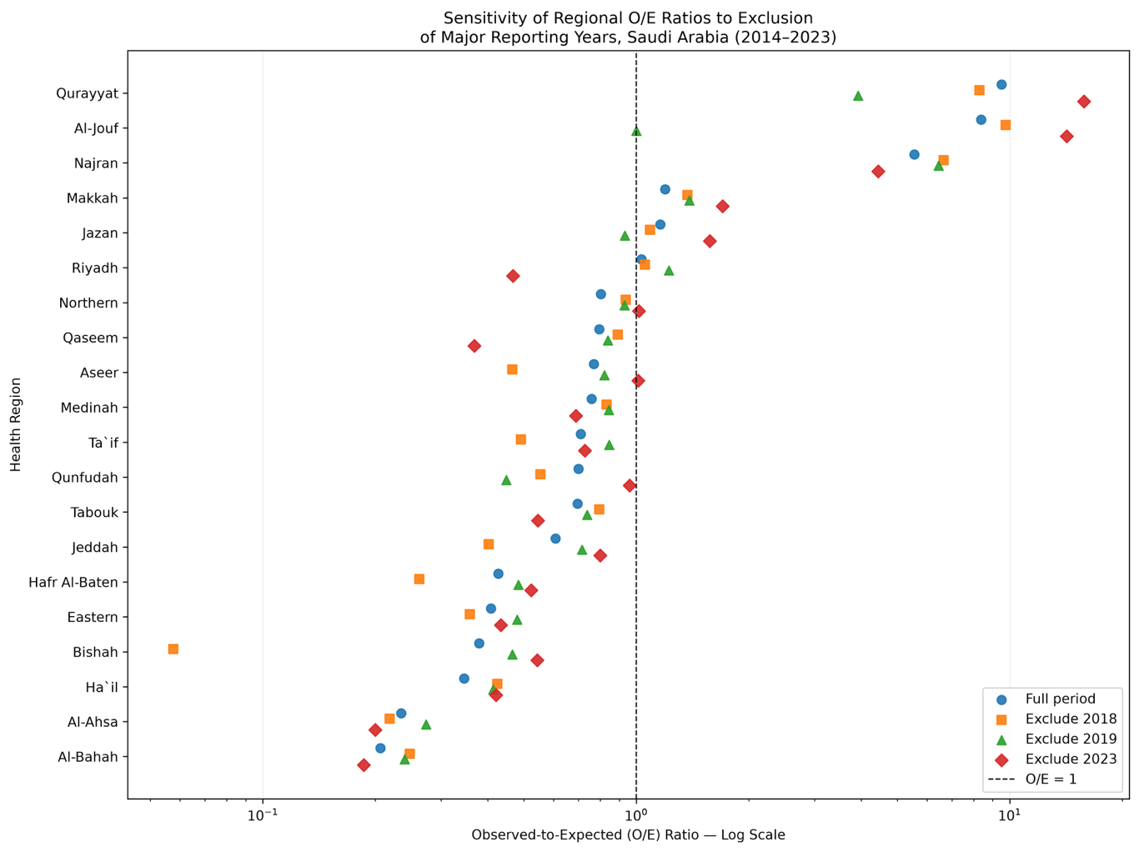
Figure 12
- Simulation-based O/E reference visualization

We generated 20,000 multinomial simulations. We kept the annual national case totals fixed and distributing cases across regions according to their population shares. The resulting O/E ratios were used to calculate 95% null reference intervals, representing the variation expected under equal population adjusted incidence across regions (Figure 13).

Regional O/E Ratios and 95% Simulation-Based Null Reference Intervals (2014–2023)
Health region | 95% null lower | 95% null upper | Observed O/E ratio
Al-Ahsa | 0.869260 | 1.131418 | 0.234562
Al-Bahah | 0.787161 | 1.225906 | 0.206468
Al-Jouf | 0.768884 | 1.242043 | 8.383791
Aseer | 0.897021 | 1.103792 | 0.769310
Bishah | 0.773783 | 1.244121 | 0.379305
Eastern | 0.926352 | 1.074055 | 0.407788
Ha`il | 0.833925 | 1.172003 | 0.345591
Hafr Al-Baten | 0.793866 | 1.220421 | 0.426555
Jazan | 0.885703 | 1.116129 | 1.159334
Jeddah | 0.935917 | 1.066250 | 0.606981
Makkah | 0.913028 | 1.088189 | 1.193286
Medinah | 0.905940 | 1.095732 | 0.759168
Najran | 0.819321 | 1.187555 | 5.551127
Northern | 0.774121 | 1.241515 | 0.803333
Qaseem | 0.880563 | 1.118335 | 0.794845
Qunfudah | 0.736065 | 1.269713 | 0.699262
Qurayyat | 0.689346 | 1.348721 | 9.500987
Riyadh | 0.957104 | 1.043527 | 1.031918
Ta`if | 0.873923 | 1.131220 | 0.709785
Tabouk | 0.852090 | 1.152122 | 0.696074
Note: The 95% null reference bounds were generated from 20,000 population-proportional multinomial simulations. These are not confidence intervals for the observed O/E ratios. Values are rounded to three decimals.
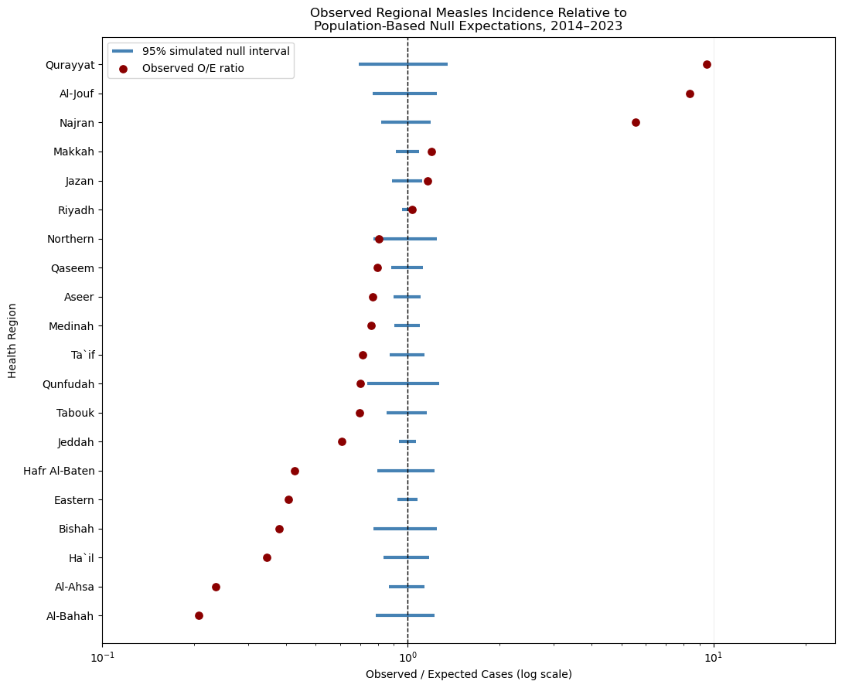
Figure 13

- Simultaneous Simulation-based reference intervals

To account for comparisons across all 20 health regions, we calculated simultaneous 95% null reference intervals using the maximum standardized deviation in each simulation (Figure 14).

$$T_{s}=\begin{matrix}max \\ r\end{matrix}\left|\frac{O_{r}^{\left(s\right)}-E_{r}}{σ_{r}}\right|$$
Were:
$O_{r}^{\left(s\right)}:$ Simulated cases in region $r$, simulation $s$.
$E_{r}:$ Expected cases in that region
$σ_{r}:$ Standard deviation under our multinomial reference model
$T_{s}:$ Largest stander deviation across all 20 regions in one simulation

Health region | Observed cases | Expected cases | O/E ratio | Null SD | Simultaneous lower 95 | Simultaneous upper 95
Qurayyat | 317 | 33,36495 | 9,500987 | 5,760056 | 0,476706 | 1,523294
Al-Jouf | 567 | 67,63051 | 8,383791 | 8,176907 | 0,633515 | 1,366485
Najran | 603 | 108,6266 | 5,551127 | 10,32756 | 0,711815 | 1,288185
Makkah | 545 | 456,7219 | 1,193286 | 20,53587 | 0,863708 | 1,136292
Jazan | 322 | 277,7456 | 1,159334 | 16,27424 | 0,822392 | 1,177608
Riyadh | 1600 | 1550,511 | 1,031918 | 33,90162 | 0,933724 | 1,066276
Northern | 55 | 68,46475 | 0,803333 | 8,226961 | 0,635765 | 1,364235
Qaseem | 204 | 256,6539 | 0,794845 | 15,67363 | 0,814889 | 1,185111
Aseer | 253 | 328,8662 | 0,76931 | 17,6301 | 0,837503 | 1,162497
Medinah | 300 | 395,1696 | 0,759168 | 19,21272 | 0,852628 | 1,147372
Ta`if | 160 | 225,4204 | 0,709785 | 14,72748 | 0,801964 | 1,198036
Qunfudah | 38 | 54,343 | 0,699262 | 7,338162 | 0,590689 | 1,409311
Tabouk | 116 | 166,649 | 0,696074 | 12,72861 | 0,76848 | 1,23152
Jeddah | 489 | 805,6269 | 0,606981 | 26,39851 | 0,900676 | 1,099324
Hafr Al-Baten | 36 | 84,39708 | 0,426555 | 9,121865 | 0,672383 | 1,327617
Eastern | 254 | 622,8733 | 0,407788 | 23,62186 | 0,885046 | 1,114954
Bishah | 25 | 65,90998 | 0,379305 | 8,073257 | 0,628715 | 1,371285
Ha`il | 46 | 133,1055 | 0,345591 | 11,40819 | 0,740205 | 1,259795
Al-Ahsa | 51 | 217,4263 | 0,234562 | 14,47504 | 0,798202 | 1,201798
Al-Bahah | 16 | 77,49369 | 0,206468 | 8,744595 | 0,657955 | 1,342045

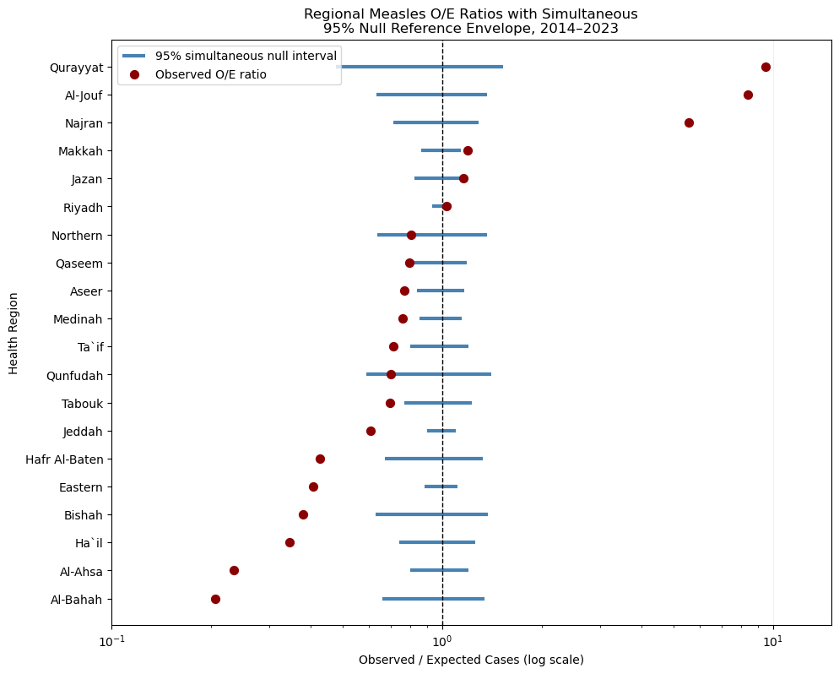
Figure 14
Empirical simultaneous coverage: 0.950
Minimum lower O/E limit: 0.47670599335743474
Independent simultaneous coverage: 0.950
Minimum SD ratio: 0.989
Maximum SD ratio: 1.01
SDs agree within 5%: True
Simulations at least as concentrated: 0
Monte Carlo upper-tail p-value: 0.000050

We ranked the regions by average annual incidence, and cumulative shares of population exposure and reported cases were plotted. The dashed diagonal indicates proportional equality, while the shaded area represents geographic concentration. The observed Gini-type concentration index was 0.369. (Figure 15).

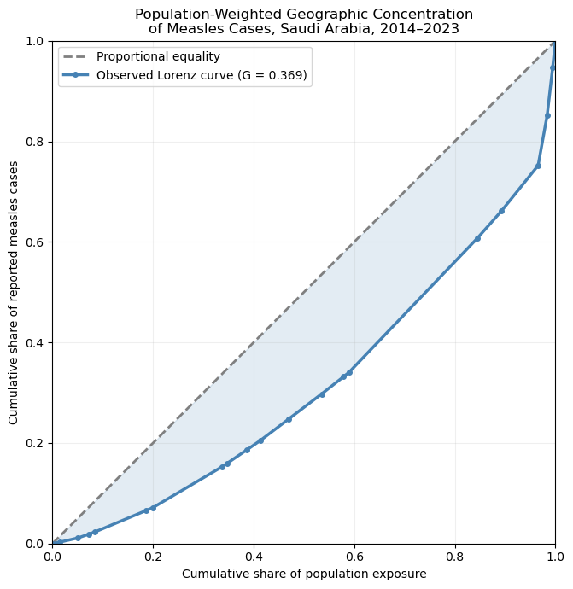
Figure 15 The population-weighted Lorenz curve of reported measles cases across 20 Saudi health regions, 2014–2023

- Population-weighted geographic concentration

In order to analise the geographic concentration, we ranked health regions by their annoual incidence rates. We used cumulative population and case shares to construct a Lorenz curve and calculate a Gini-type concentration index. The observed index was compared with results from 20,000 population-proportional simulations (Figure 16).

Regional Measles Cases, Population Shares, and Incidence Rates
Health region | Total cases | Population exposure | Incidence per 100k | Population share | Case share
Al-Bahah | 16 | 4531270 | 0,353102 | 0,013860 | 0,002668
Al-Ahsa | 51 | 12132673 | 0,420353 | 0,037109 | 0,008504
Ha`il | 46 | 7143656 | 0,643928 | 0,021850 | 0,007671
Bishah | 25 | 3775568 | 0,662152 | 0,011548 | 0,004169
Eastern | 254 | 33105189 | 0,767251 | 0,101257 | 0,042355
Hafr Al-Baten | 36 | 4563071 | 0,788942 | 0,013957 | 0,006003
Jeddah | 489 | 45118915 | 1,083803 | 0,138002 | 0,081541
Qunfudah | 38 | 3056697 | 1,243172 | 0,009349 | 0,006337
Ta`if | 160 | 12735124 | 1,256368 | 0,038952 | 0,026680
Tabouk | 116 | 9147824 | 1,268061 | 0,027980 | 0,019343
Aseer | 253 | 18168190 | 1,392544 | 0,055570 | 0,042188
Medinah | 300 | 21473746 | 1,397055 | 0,065680 | 0,050025
Qaseem | 204 | 14181605 | 1,438483 | 0,043376 | 0,034017
Northern | 55 | 3722828 | 1,477372 | 0,011387 | 0,009171
Riyadh | 1600 | 83417447 | 1,918064 | 0,255144 | 0,266800
Jazan | 322 | 15528022 | 2,073670 | 0,047495 | 0,053694
Makkah | 545 | 23919901 | 2,278438 | 0,073162 | 0,090879
Najran | 603 | 5906522 | 10,209054 | 0,018066 | 0,100550
Al-Jouf | 567 | 3551052 | 15,967099 | 0,010861 | 0,094547
Qurayyat | 317 | 1763900 | 17,971540 | 0,005395 | 0,052860

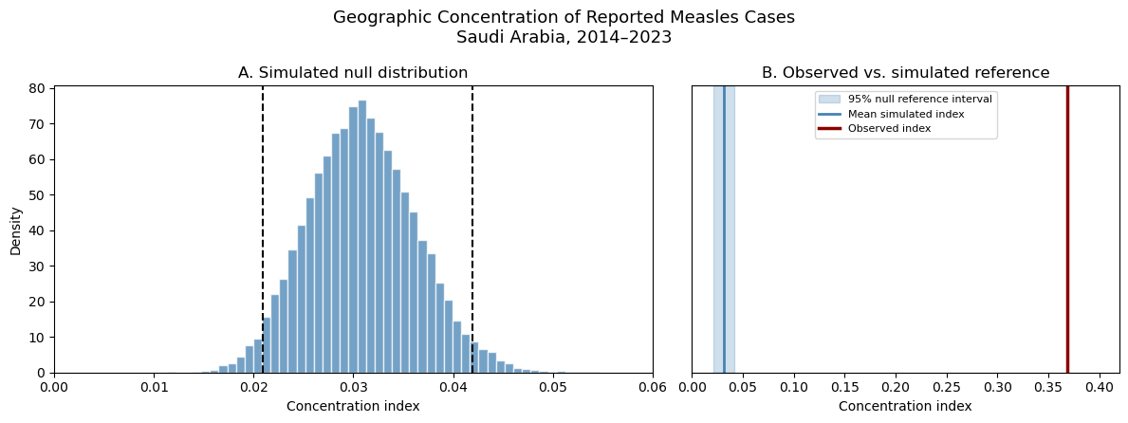
Figure 16
- Geospatial Visualization

Regional measles incidence was visualized using choropleth maps of the 20 health regions. The visualizations is include a ten year average annual incidence map (Figure 17), annual maps with a consistent color scale (Figure 18), and an interactive map for exploring yearly changes (Figure 19). Provisional health-region boundaries were reconstructed from governorate-level geographic data.

  - Geospatial Visualization of Regional Measles Incidence

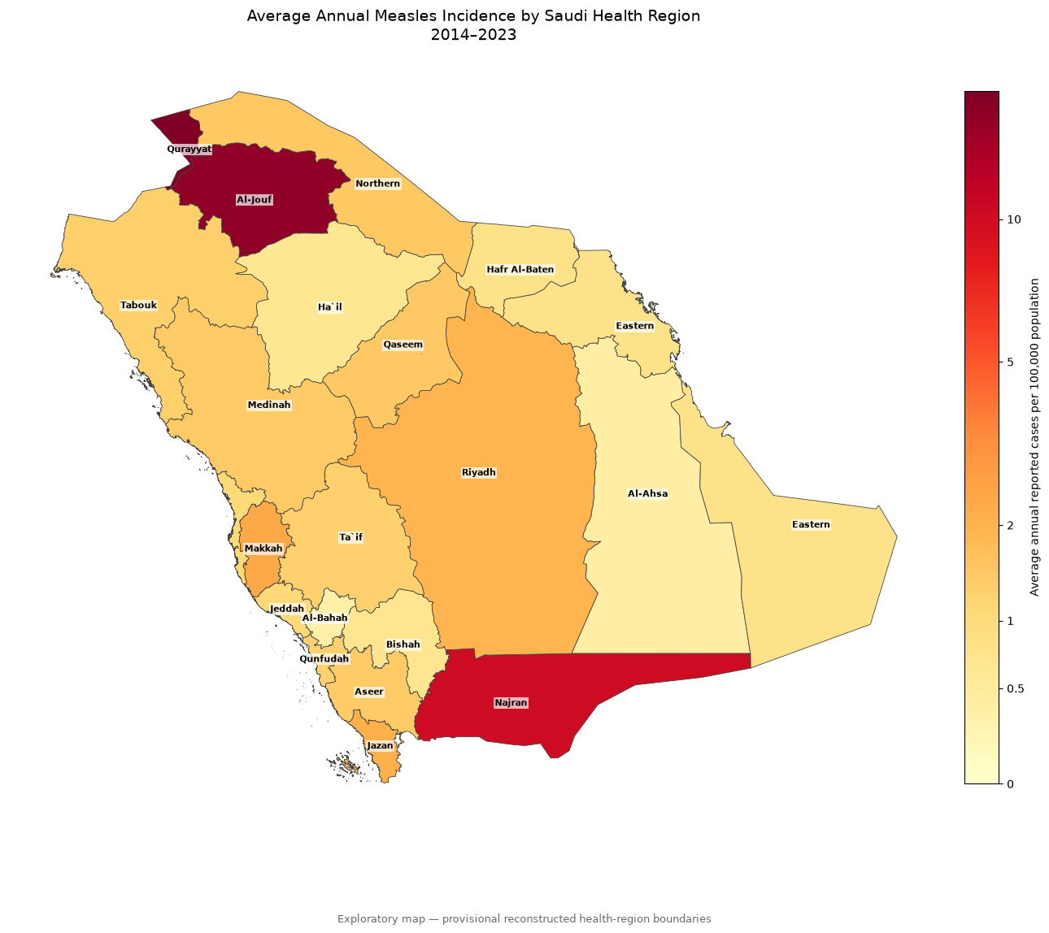
Figure 17

  - Geospatial Visualization of Regional Measles Incidence
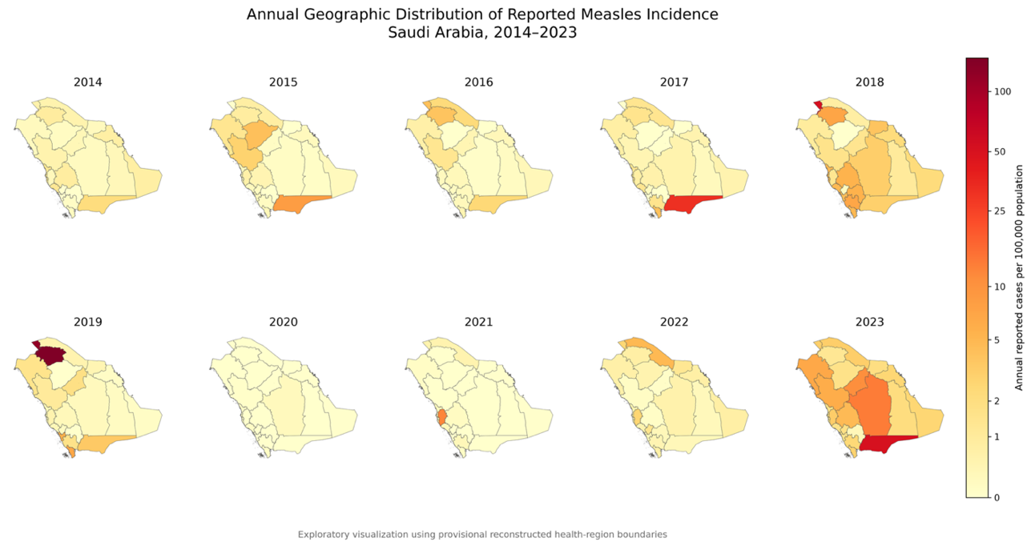
Figure 18
  - Interactive annual geographic incident map
Click here to view the interactive map
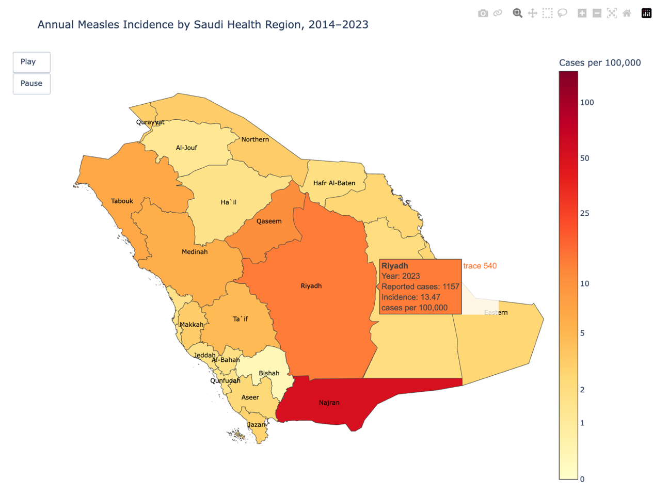
Figure 19
- Geographic Distribution of Observed-to-Expected Ratios

Regional observed-to-expected (O/E) ratios were displayed on a choropleth map using a diverging color scale. Values above 1 indicate more reported cases than expected, while values below 1 indicate fewer. A logarithmic transformation was applied to improve the visualization of differences between regions (Figure 20).
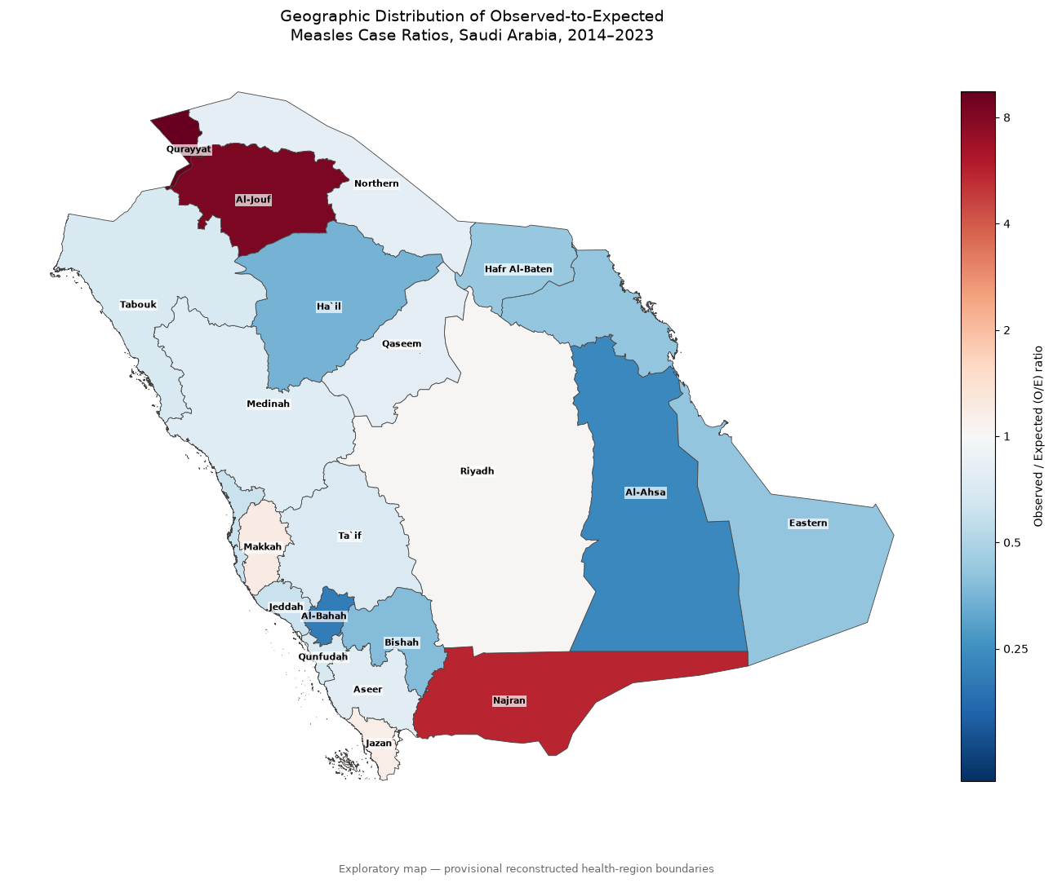
Figure 20

- Geographic Classification of O/E Deviations

We classifed the health regions as abouve, within, or below the simulataneous 95% null reference base on their O/E ratios. We then displayed the classifcations on a map to highlight the regional deviations from the population-adjusted null expectation (Figure 21).

Classification of Health Regions Based on Simultaneous 95% O/E Null Reference Intervals
Health region | Observed Cases | Expected Cases | O/E Ratio | Simultaneous 95% Null Lower | Simultaneous 95% Null Upper | Classification
Qurayyat | 317 | 33,36495 | 9,500987 | 0,476706 | 1,523294 | Higher than null reference
Al-Jouf | 567 | 67,63051 | 8,383791 | 0,633515 | 1,366485 | Higher than null reference
Najran | 603 | 108,6266 | 5,551127 | 0,711815 | 1,288185 | Higher than null reference
Makkah | 545 | 456,7219 | 1,193286 | 0,863708 | 1,136292 | Higher than null reference
Jazan | 322 | 277,7456 | 1,159334 | 0,822392 | 1,177608 | Within null reference
Riyadh | 1600 | 1550,511 | 1,031918 | 0,933724 | 1,066276 | Within null reference
Northern | 55 | 68,46475 | 0,803333 | 0,635765 | 1,364235 | Within null reference
Qaseem | 204 | 256,6539 | 0,794845 | 0,814889 | 1,185111 | Lower than null reference
Aseer | 253 | 328,8662 | 0,76931 | 0,837503 | 1,162497 | Lower than null reference
Medinah | 300 | 395,1696 | 0,759168 | 0,852628 | 1,147372 | Lower than null reference
Ta`if | 160 | 225,4204 | 0,709785 | 0,801964 | 1,198036 | Lower than null reference
Qunfudah | 38 | 54,343 | 0,699262 | 0,590689 | 1,409311 | Within null reference
Tabouk | 116 | 166,649 | 0,696074 | 0,76848 | 1,23152 | Lower than null reference
Jeddah | 489 | 805,6269 | 0,606981 | 0,900676 | 1,099324 | Lower than null reference
Hafr Al-Baten | 36 | 84,39708 | 0,426555 | 0,672383 | 1,327617 | Lower than null reference
Eastern | 254 | 622,8733 | 0,407788 | 0,885046 | 1,114954 | Lower than null reference
Bishah | 25 | 65,90997 | 0,379305 | 0,628715 | 1,371285 | Lower than null reference
Ha`il | 46 | 133,1055 | 0,345591 | 0,740205 | 1,259795 | Lower than null reference
Al-Ahsa | 51 | 217,4263 | 0,234562 | 0,798202 | 1,201798 | Lower than null reference
Al-Bahah | 16 | 77,49369 | 0,206468 | 0,657955 | 1,342045 | Lower than null reference

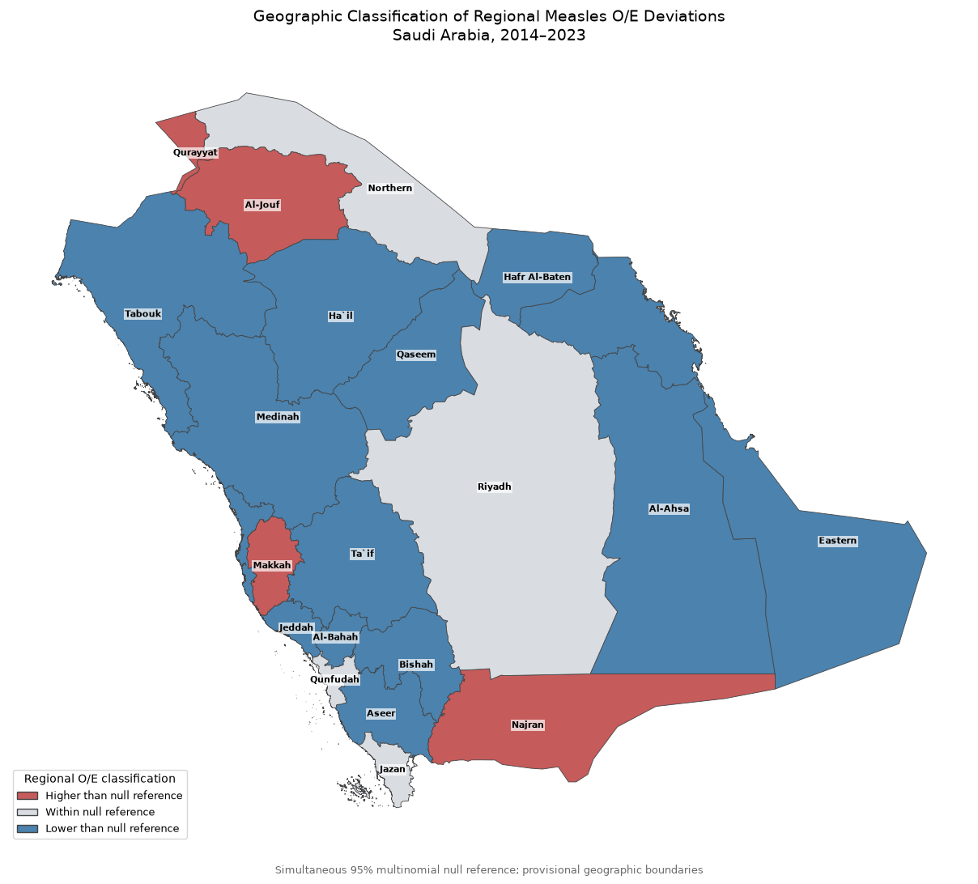
Figure 21

